Abstract:
The present invention proposes HANUMA (Hazard Analysis and Navigation Unit for Mine Assistance), a robotic inspection system designed for monitoring hazardous conditions in underground mining environments. The system comprises a mobile rover platform equipped with multiple environmental sensors for detecting methane, carbon monoxide, oxygen concentration, temperature, humidity, vibration, dust density, and light intensity within underground tunnels. The rover integrates embedded processing units for sensor acquisition, data processing, and visual surveillance using an onboard camera system.
To address the communication challenges commonly encountered in underground mines, the system uses a relay-node–based mesh architecture that enables reliable node-to-node data transmission between the rover and a remote-control station. The architecture also incorporates local data buffering mechanisms to store sensor readings during communication interruptions and automatically transmit the stored data once network connectivity is restored.
A real-time monitoring interface is developed using a web-based telemetry dashboard to visualise rover navigation data, environmental parameters, and communication status for remote operators. In addition to hardware implementation, the system is validated through a robotics simulation environment that models rover mobility, terrain interaction, and sensor behaviour within a virtual mine environment. The proposed system enables safe remote inspection of hazardous mine zones, thereby reducing human exposure and improving operational safety in underground mining operations.

Novelty:
Integrated Robotic Mine Inspection Architecture:
- The invention introduces an integrated inspection architecture that combines a multi-sensor robotic rover, a wireless communication framework, and a centralised monitoring interface for real-time assessment of underground mine environments.
Relay Node–Based Mesh Communication Network
- The system incorporates a distributed relay-node mesh communication architecture that enables node-to-node data transmission between the rover and the surface control station, ensuring reliable data delivery despite signal attenuation within underground tunnels
Adaptive Data Buffering and Recovery Mechanism
- A local data buffering mechanism is implemented within the onboard embedded processors to temporarily store environmental and visual data during communication interruptions, with automatic retransmission when network connectivity is restored.
Multi-Sensor Hazard Detection Framework
- The rover integrates multiple environmental sensing modules capable of detecting methane, carbon monoxide, oxygen concentration, dust density, vibration levels, temperature, humidity, and illumination conditions, enabling comprehensive hazard monitoring within underground mining environments.
Hybrid Embedded Processing System
- The invention employs a hybrid embedded computing architecture combining microcontroller-based sensor acquisition with high-level embedded processing for data management, communication control, and visual monitoring.
Real-Time Telemetry and Monitoring Dashboard
- A web-based telemetry interface is developed using a structured HTML-based monitoring platform that visualises rover navigation data, environmental sensor readings, gas concentration trends, communication signal strength, and operational status in real time.
Interactive Environmental Analytics and Visualisation
- The system provides dynamic visualisation of environmental parameters, including gas concentration trends, atmospheric composition, obstacle sensing data, and mission alerts through graphical dashboards, improving situational awareness for mine operators.
Integrated Data Logging and Analysis Framework
- The monitoring system includes a data logging module capable of recording sensor measurements, rover coordinates, and operational parameters for further analysis, enabling long-term environmental assessment and safety evaluation.
Simulation-Assisted System Validation
- A virtual simulation environment is developed using robotics simulation software to evaluate rover mobility, terrain interaction, and sensor behaviour under simulated underground mining conditions before real-world deployment.

Safety-Oriented Remote Mine Inspection System
- The proposed system enables remote inspection and hazard assessment of underground tunnels before human entry, thereby reducing exposure of mine workers to toxic gases, unstable terrain, and hazardous environmental conditions.
Methodology:
Hardware Implementation Methodology
The hardware architecture of the proposed HANUMA system is organised into functional modules responsible for sensing, processing, mobility, communication, and power management.
Step 1: Environmental Sensing Module
Multiple environmental sensors are deployed on the rover platform to monitor underground mine conditions. The sensing unit measures methane concentration, carbon monoxide levels, oxygen concentration, temperature, humidity, dust density, vibration, and ambient light intensity.
Step 2: Data Acquisition and Processing Unit
The sensor outputs are interfaced with embedded processing units responsible for acquiring sensor signals and performing preliminary data processing. The processing unit also manages noise reduction and filtering to improve measurement reliability.
Step 3: Mobility and Navigation System
The rover platform includes motor drivers and wheel mechanisms that enable controlled movement across uneven mine terrain. The navigation system allows remote operation of the rover within underground tunnels.
Step 4: Visual Surveillance Module
A camera module integrated with the processing unit captures visual information of tunnel conditions and the surrounding environments for remote monitoring.
Step 5: Communication Network Architecture
A relay node–based mesh communication network is implemented to transmit sensor data and telemetry information between the rover and the control station. Relay nodes positioned along the tunnel forward data between intermediate nodes to maintain communication reliability.
Step 6: Data Storage and Recovery Mechanism
During temporary communication loss, the system stores sensor data locally within the onboard memory and automatically transmits the stored data once connectivity with relay nodes is restored.
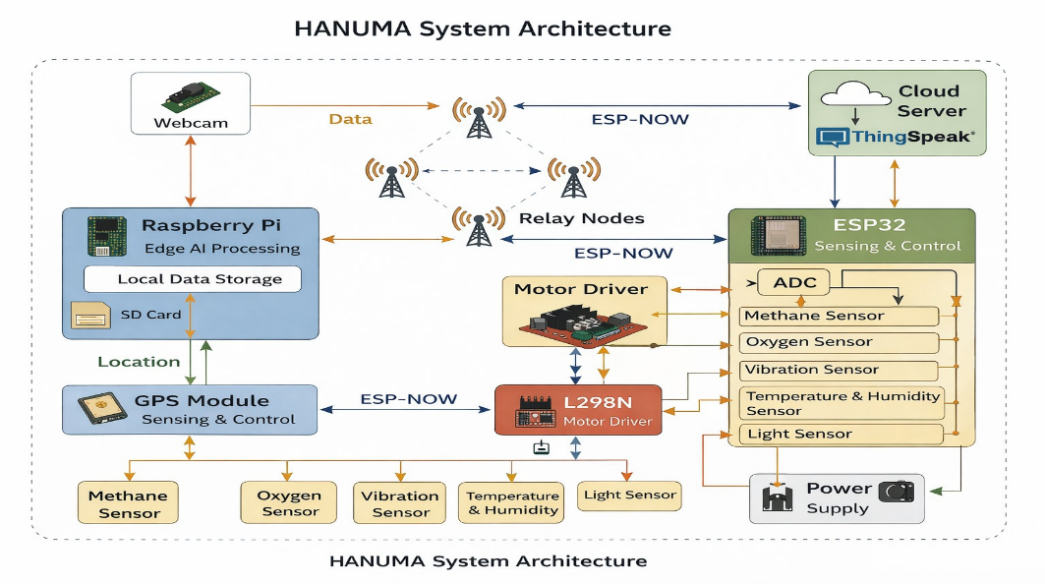
Software and Simulation Methodology
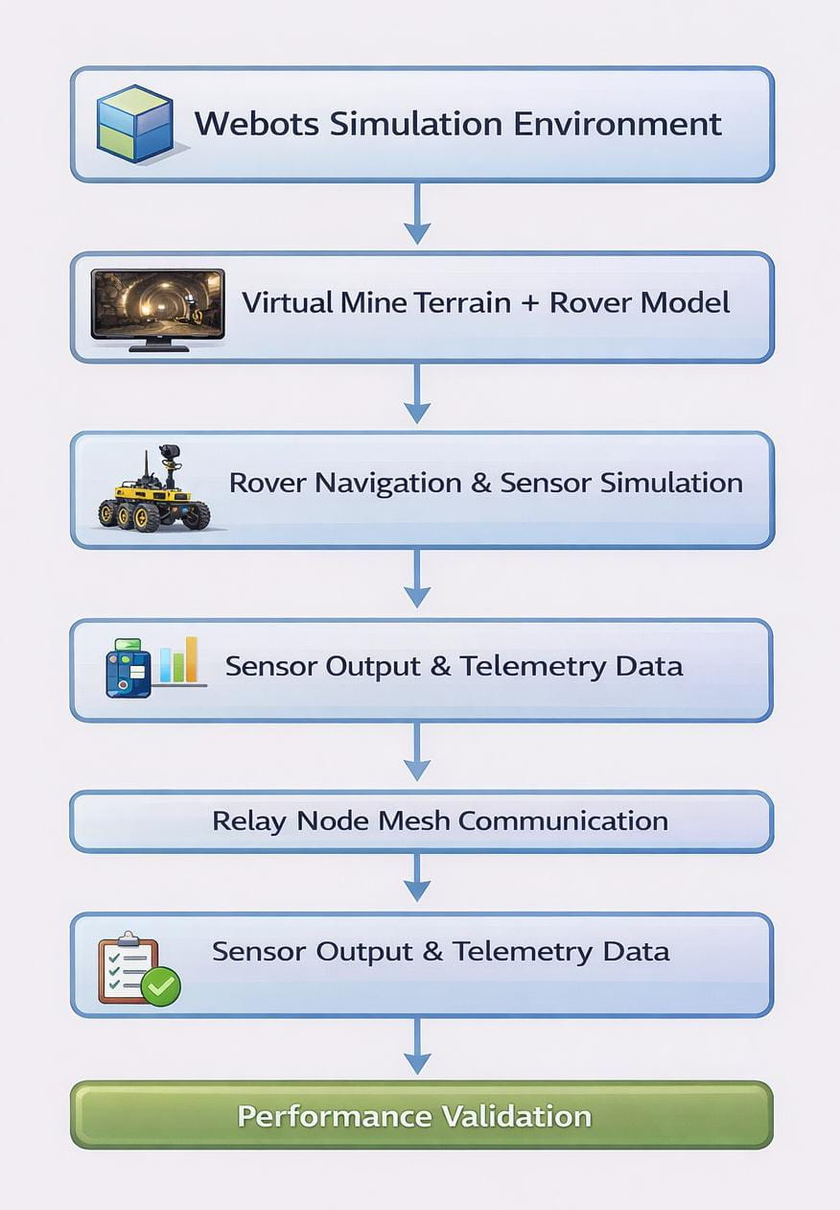

Sensor Data Processing: Sensor readings are processed using noise filtering techniques to improve measurement accuracy and stability.
Monitoring Interface: A web-based dashboard is developed to visualise environmental parameters, rover telemetry, and communication status in real time.
Data Visualisation: Environmental data, such as gas concentration and system parameters, are displayed through graphical monitoring tools.
Simulation Environment: A virtual mine environment is created using a robotics simulation platform to model terrain, obstacles, and underground conditions.
System Validation: Simulation outputs are used to evaluate rover mobility, sensor response, and overall system performance before real-world deployment.

Results & Deliverable Outcomes:
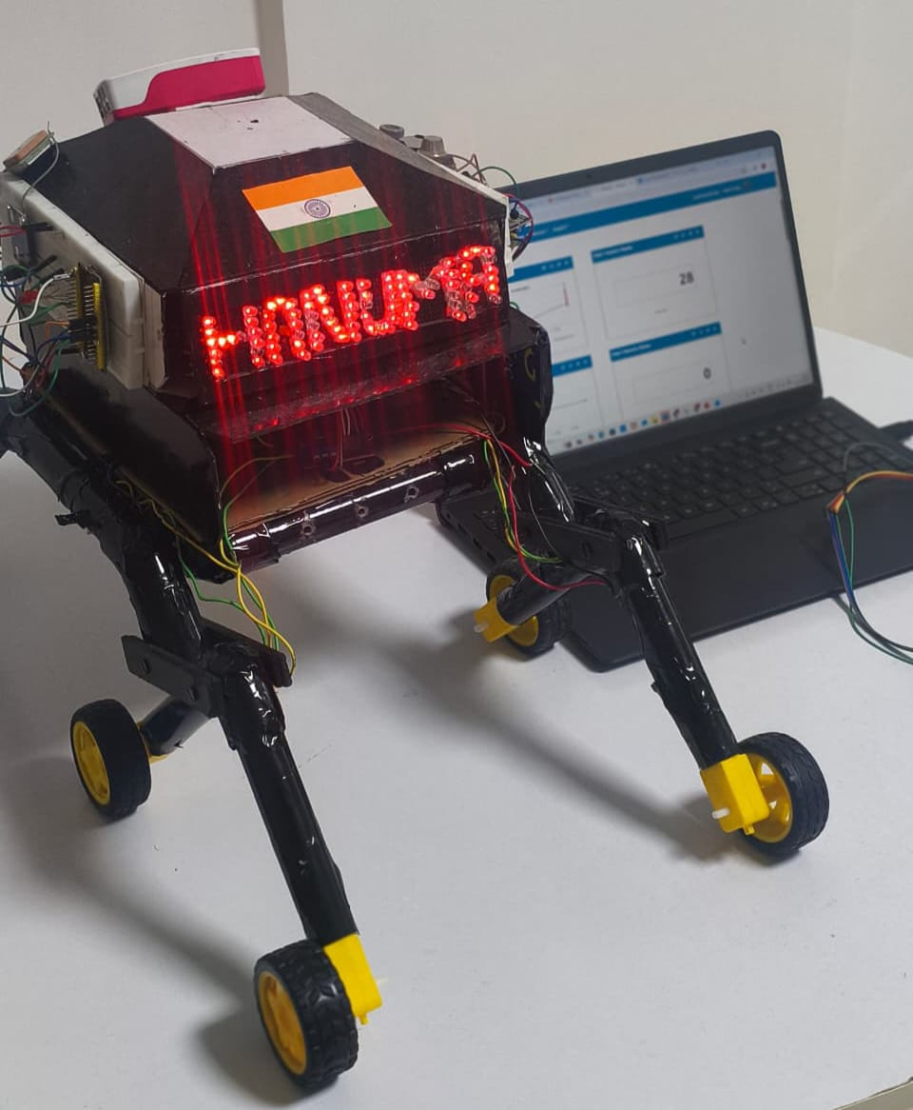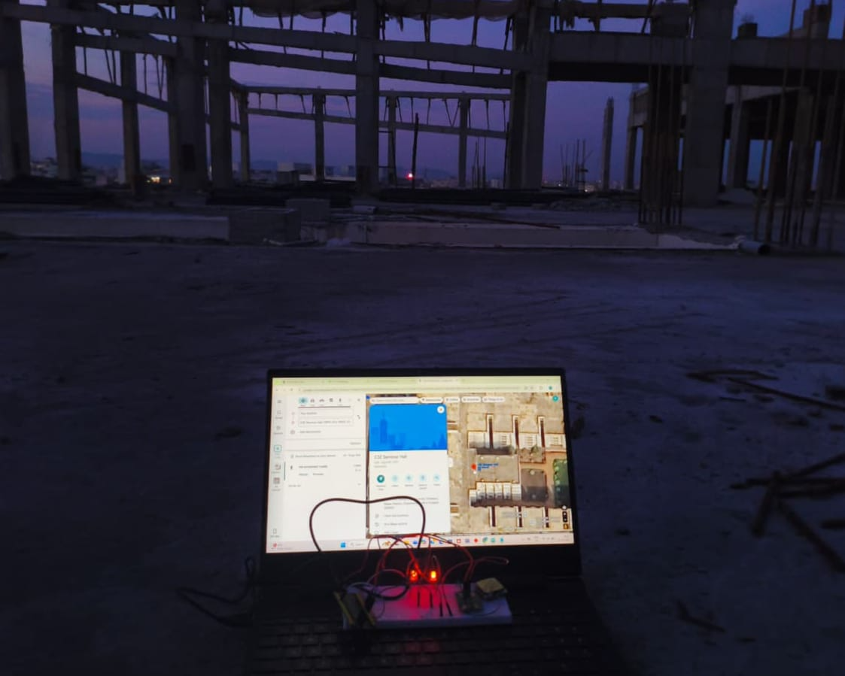
Fig 1: Hardware Prototype Fig 3: Integration of GPS with ESP-32
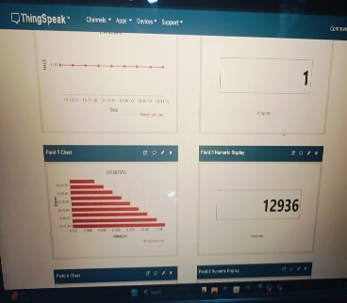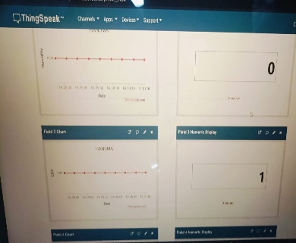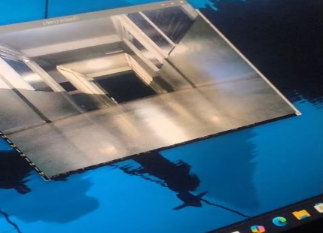
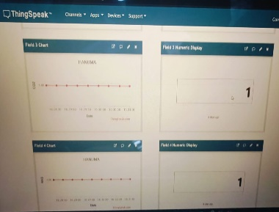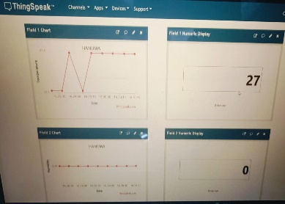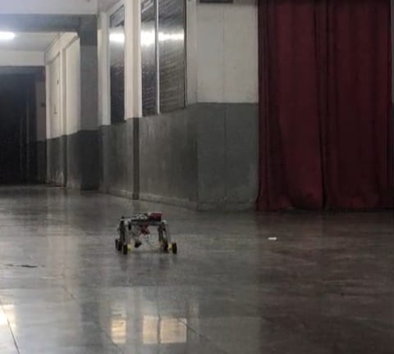
Fig 2: Thingspeak Sensors Readings Fig 4: Camera Integration with Pi5

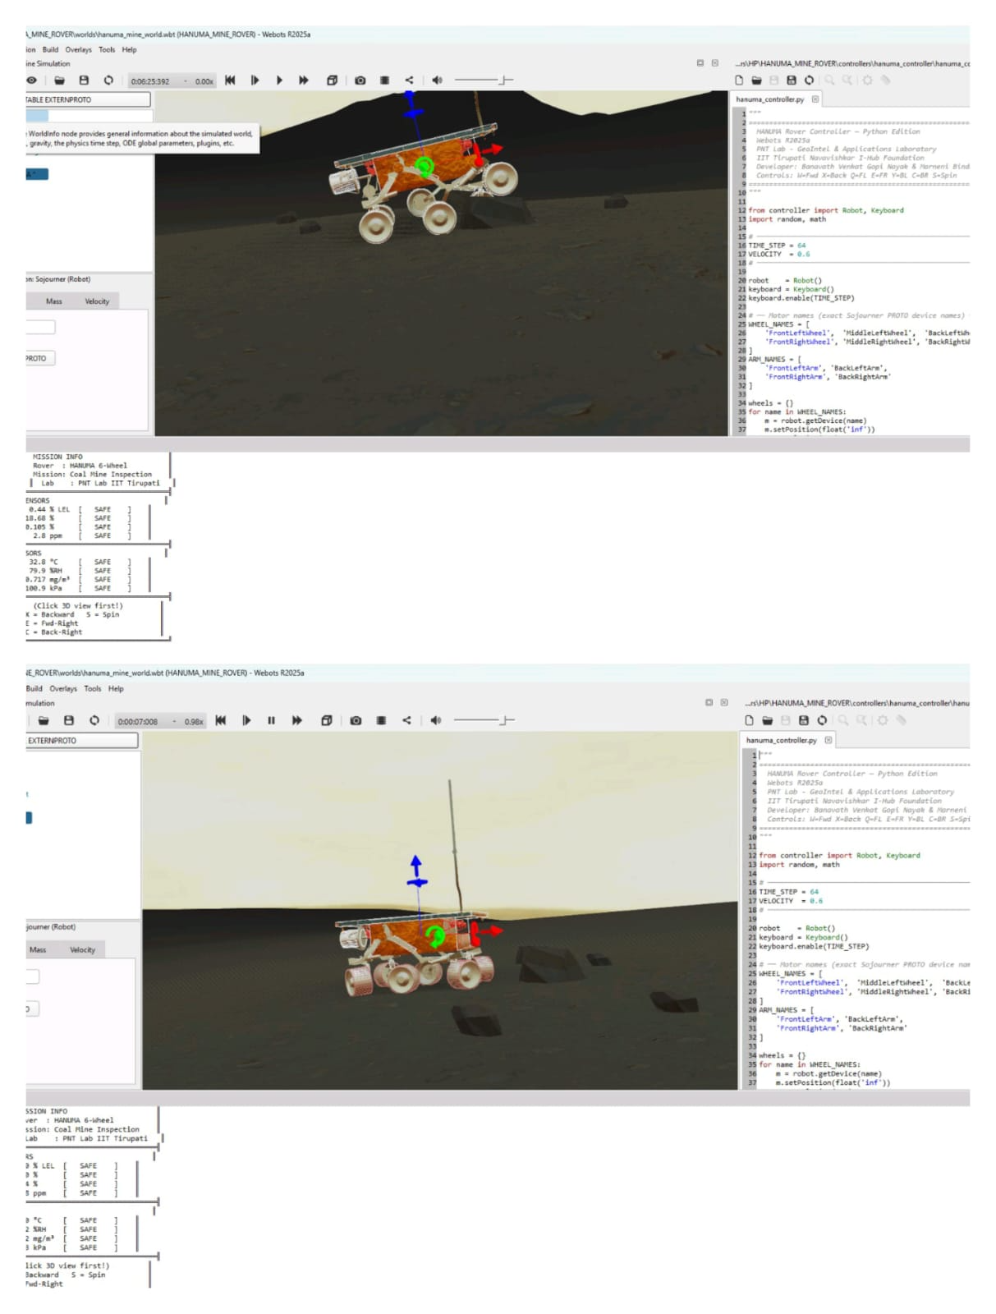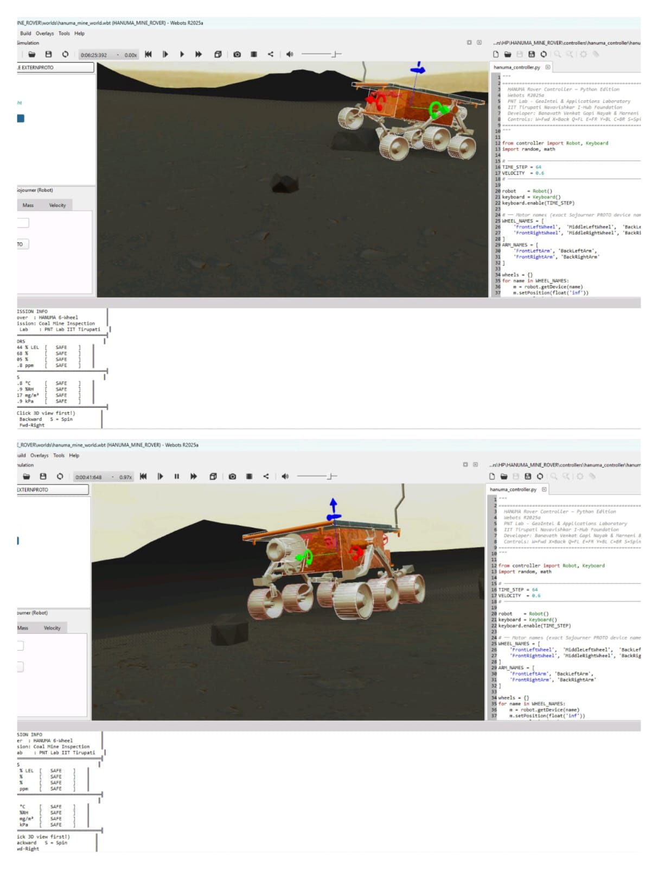
Fig. 5: Webots-based simulation of the HANUMA rover used for evaluating rover navigation and terrain interaction in a virtual underground mine environment.
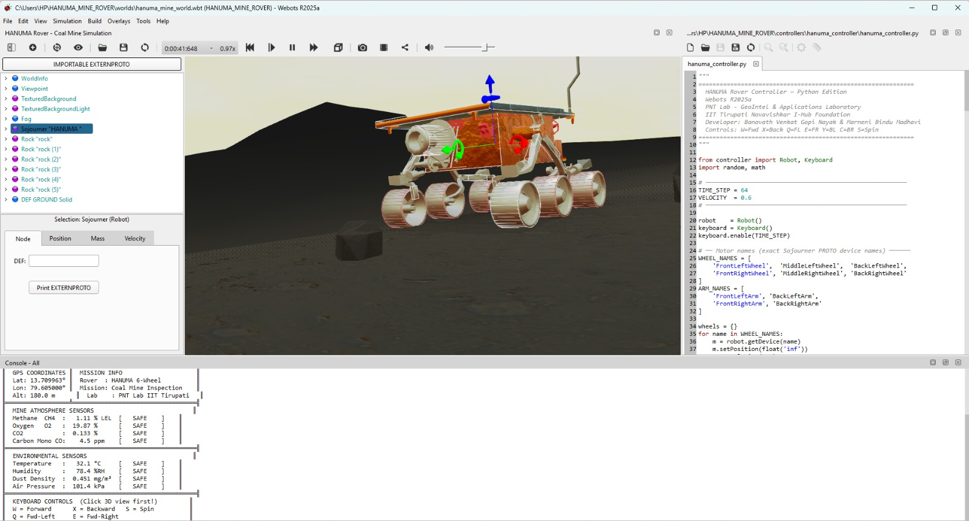
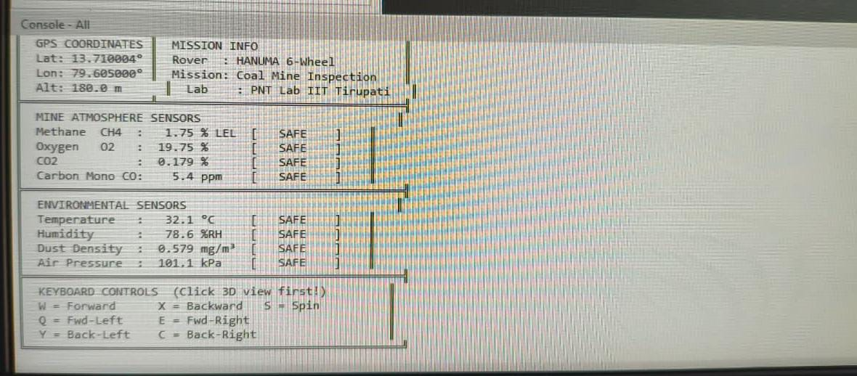Fig.6: Simulation output displaying rover telemetry, environmental sensor measurements, and mission status generated during the Webots-based HANUMA rover simulation.
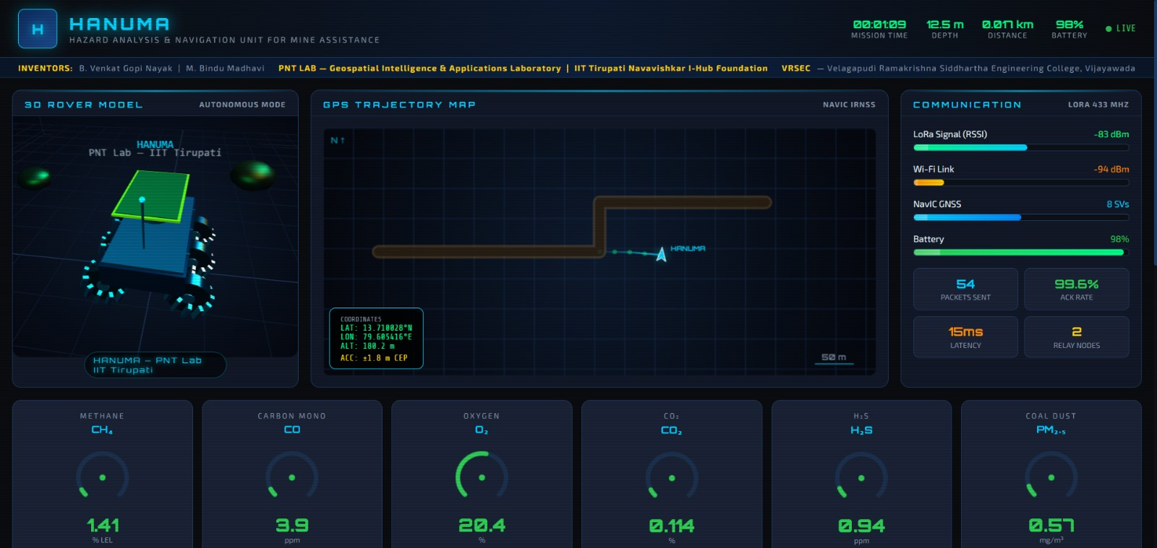
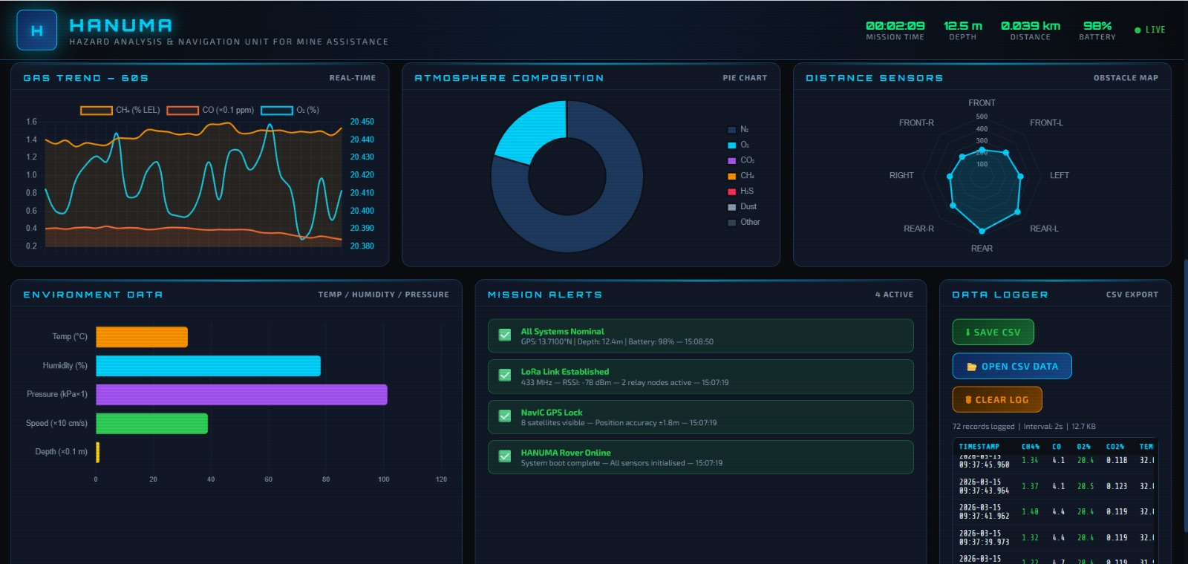
Fig. 7: Web-based telemetry dashboard of the HANUMA system displaying rover navigation data, environmental sensor measurements, and communication status in real time.

